The Additive Inverse of an Integer
The negative of any number is the additive inverse of that number.
The additive inverse of 5 is (- 5) and additive inverse of (- 5) is 5.
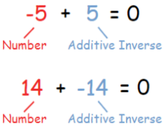
This shows that the number which we add to a number to get zero is the additive inverse of that number.
Number | Additive Inverse
5 | - 5
14 | - 14
- 10 | 10
- 6 | 6

